**5 Bus Book Case without HVDC Light**

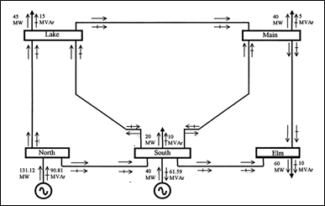

Results

|  |  |  |  |  |  |
| --- | --- | --- | --- | --- | --- |
| Information | North | South | Lake | Main | Elm |
| |V| (p.u.) | 1.06 | 1.00 | 0.987 | 0.984 | 0.972 |
| Θ (degrees) | 0.00 | -2.06 | -4.64 | -4.96 | -5.76 |
| P (p.u.) | 1.311 | 0.200 | -0.450 | -0.400 | -0.600 |
| ΔP (p.u.) |  | -1.64e-13 | -4.51e-14 | -1.88e-14 | 2.63e-14 |
| Q (p.u.) | 0.908 | -0.716 | -0.150 | -0.050 | -0.100 |
| ΔQ (p.u.) |  | 0.616 | -1.613e-13 | -3.393e-14 | 7.780e-14 |



**5 Bus Book Case with HVDC Light**

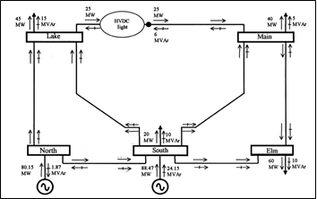

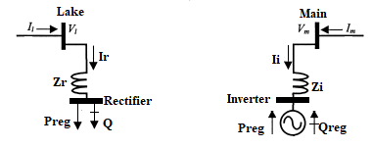

Rectifier is connected to Lake using Zr. Rectifier is modeled as a PQ node to draw desired power Preg=0.25 p.u. from Lake. The voltage of Lake node |Vl| is regulated at 1 p.u.

$$V_{r}=|V_{r}|(cosθ_{r}+jsinθ_{r})$$

Inverter is connected to Main using Zi. Inverter is modeled as a PV node to deliver desired active power Preg=0.25 p.u. and absorb desired reactive power Qreg=-0.06 p.u.

The Converters are lossless hence no active power is lost between the Rectifier and Inverter.

The State Variables are the Rectifier phase angle and Inverter Voltage Magnitude. The Rectifier phase angle and Inverter Voltage Magnitude are updated after every iteration:

$$θ_{r}^{n+1}=θ_{r}^{n}+{∆θ}_{r}^{n}$$

$${|V_{i}|}^{r+1}={|V_{i}|}^{r}+{∆|V_{i}|}^{r}$$

Results

|  |  |  |  |  |  |  |  |
| --- | --- | --- | --- | --- | --- | --- | --- |
| Information | North | South | Lake | Main | Elm | Rectifier | Inverter |
| |V| (p.u.) | 1.036 | 1.029 | 1.000 | 1.003 | 0.998 | 1.005 | 1.006 |
| Θ (degrees) | 0.00 | -1.41 | -4.64 | -3.55 | -4.72 | 6.20 | -2.50 |
| P (p.u.) | 0.7978 | 0.6789 | -0.4397 | -0.400 | -0.600 | -0.251 | 0.250 |
| ΔP (p.u.) |  | 0.0058 | -0.0103 | -1.44e-15 | -1.22e-15 | 0.00104 | 4.44e-16 |
| Q (p.u.) | -0.029 | 0.1736 | -0.120 | -0.050 | -0.100 | -0.031 | -0.06 |
| ΔQ (p.u.) |  | -0.2736 | -0.0302 | -8.17e-15 | 4.96e-15 | 0.0305 | 2.28e-15 |





**IEEE 14 Bus System without HVDC Light**

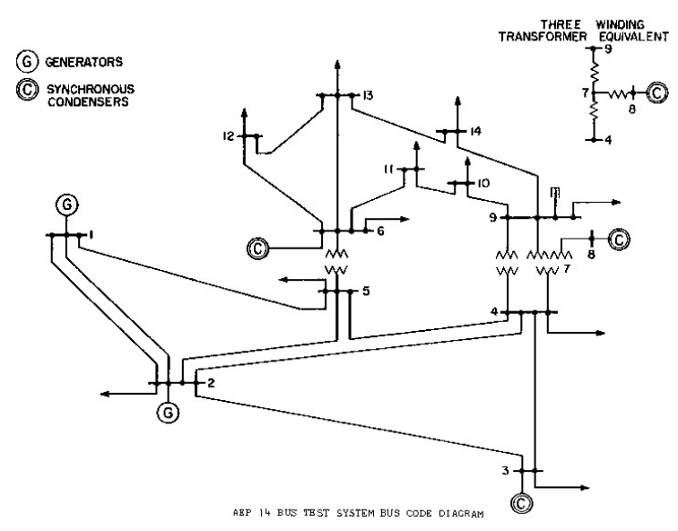

The system consists of 14 buses, 2 generators, 3 synchronous condensers, 11 loads, three transformers and 3 phase shifters. The Generators and Synchronous condensers can deliver active and reactive powers for regulating constant 1.06 p.u. voltage magnitudes at their respective buses.

Results

|  |  |  |  |  |  |  |  |  |  |  |  |  |  |  |
| --- | --- | --- | --- | --- | --- | --- | --- | --- | --- | --- | --- | --- | --- | --- |
| Information | 1 | 2 | 3 | 4 | 5 | 6 | 7 | 8 | 9 | 10 | 11 | 12 | 13 | 14 |
| |V| (p.u.) | 1.060 | 1.060 | 1.060 | 1.048 | 1.048 | 1.060 | 1.040 | 1.060 | 1.024 | 1.024 | 1.039 | 1.049 | 1.043 | 1.021 |
| Θ (degrees) | 0.00 | -6.44 | -15.8 | -13.1 | -11.2 | -17.1 | -16.3 | -16.3 | -18.1 | -18.5 | -18.1 | -18.6 | -18.9 | -20.3 |
| P (p.u.) | 2.44 | 0.183 | -0.942 | -0.478 | -0.076 | -0.112 | 0 | 0 | -0.295 | -0.090 | -0.035 | -0.061 | -0.135 | -0.149 |
| ΔP (p.u.) |  | 6e-16 | -3e-15 | -4e-15 | 5e-16 | 2e-15 | -8e-16 | 1e-16 | -6e-15 | 1e-15 | -5e-16 | -6e-16 | -3e-16 | 4e-16 |
| Q (p.u.) | 0.213 | 0.309 | 0.119 | 0.039 | -0.016 | 0.274 | 0 | 0.123 | -0.166 | -0.058 | -0.018 | -0.016 | -0.058 | -0.050 |
| ΔQ (p.u.) |  | -0.01 | -0.075 | 4e-15 | -6e-15 | -0.227 | 0 | 0.050 | 3e-15 | -1e-15 | 6e-16 | 9e-16 | -1e-15 | -2e-15 |



**IEEE 14 Bus System with HVDC Light**

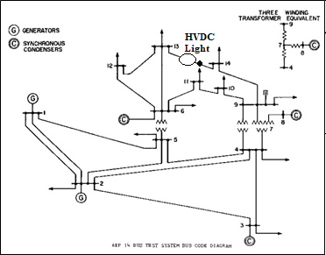

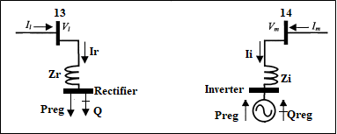

Rectifier is connected to bus 13 using Zr. Rectifier is modeled as a PQ node to draw desired power Preg=0.25 p.u. from Lake. The voltage of bus 13 is regulated at 1.06 p.u.

$$V_{r}=|V_{r}|(cosθ_{r}+jsinθ_{r})$$

Inverter is connected to bus 14 using Zi. Inverter is modeled as a PV node to deliver desired active power Preg=0.25 p.u. and absorb desired reactive power Qreg=-0.06 p.u.

The Converters are lossless hence no active power is lost between the Rectifier and Inverter.

The State Variables are the Rectifier phase angle and Inverter Voltage Magnitude. The Rectifier phase angle and Inverter Voltage Magnitude are updated after every iteration:

$$θ_{r}^{n+1}=θ_{r}^{n}+{∆θ}_{r}^{n}$$

$${|V_{i}|}^{r+1}={|V_{i}|}^{r}+{∆|V_{i}|}^{r}$$

Results

|  |  |  |  |  |  |  |  |  |  |  |  |  |  |  |  |  |
| --- | --- | --- | --- | --- | --- | --- | --- | --- | --- | --- | --- | --- | --- | --- | --- | --- |
| Information | 1 | 2 | 3 | 4 | 5 | 6 | 7 | 8 | 9 | 10 | 11 | 12 | 13 | 14 | Rectifier | Inverter |
| |V| (p.u.) | 1.060 | 1.060 | 1.060 | 1.048 | 1.048 | 1.060 | 1.034 | 1.060 | 1.011 | 1.013 | 1.033 | 1.056 | 1.060 | 0.965 | 1.060 | 1.007 |
| Θ (degrees) | 0.00 | -5.85 | -14.8 | -12.1 | -10.6 | -18.1 | -14.7 | -14.7 | -16.1 | -17.0 | -17.8 | -20.3 | -21.5 | -13.9 | -21.6 | -13.2 |
| P (p.u.) | 2.20 | 0.183 | -0.942 | -0.478 | -0.076 | -0.112 | 0 | 0 | -0.295 | -0.090 | -0.035 | -0.061 | -0.135 | -0.149 | -0.250 | 0.250 |
| ΔP (p.u.) |  | -8e-10 | -1e-9 | 1e-9 | -6e-10 | -2e-5 | -6e-9 | -1e-9 | 2e-9 | 5e-10 | 6e-10 | -4e-6 | 1e-5 | -3e-7 | 2e-5 | 1e-7 |
| Q (p.u.) | 0.126 | 0.182 | 0.080 | 0.039 | -0.016 | 0.195 | 0 | 0.157 | -0.166 | -0.058 | -0.018 | -0.018 | 0.020 | -0.050 | 0.0003 | -0.060 |
| ΔQ (p.u.) |  | 0.211 | 0.270 | 1e-9 | 1e-8 | -0.291 | 1.5e-7 | -0.116 | -2e-8 | -9e-9 | 4e-8 | 2e-4 | -0.01 | -8e-8 | -2e-4 | -1e-8 |



